Your Name
[Email address]

Final Project
Statistics for Business Analytics

Contents
Introduction 3
Descriptive Analysis 5
Hypothesis Testing 8
ANOVA 9
Regression Analysis 10
Conclusion 13
References 14

Introduction
In recent years, understanding shopping trends has become increasingly vital for businesses seeking to optimize their strategies and cater to evolving consumer preferences. By employing statistical methods such as hypothesis testing, ANOVA (Analysis of Variance), and multiple linear regression, analysts can decipher complex patterns in consumer behavior. Hypothesis testing serves as a fundamental tool to assess the significance of observed trends and discern whether they reflect genuine patterns or mere coincidences. ANOVA offers a powerful means to compare differences among groups, crucial for understanding how distinct market segments respond to various products or marketing strategies. Lastly, Multiple linear regression allows for the examination of how various factors simultaneously influence shopping trends, providing a multifaceted view of consumer decision-making. Together, these statistical techniques offer a comprehensive framework for interpreting and leveraging shopping trends in today's dynamic market environment.
A similar study conducted by Moshref Javadi et al. (2012) offers significant insights into the factors influencing consumer behavior in online shopping. The research delves into the complex interplay of perceived risks, infrastructural variables, and return policies on consumer attitudes toward online shopping. The authors used a comprehensive model to assess how these factors, along with subjective norms, perceived behavioral control, and domain-specific innovativeness, impact online shopping behaviors. The researchers distributed 200 questionnaires among online store consumers in Iran, employing regression analysis to test their hypotheses. The findings revealed that financial risks and the risk of non-delivery negatively influenced consumers' attitudes toward online shopping. Conversely, factors such as domain-specific innovativeness and subjective norms were found to positively affect online shopping behavior, underlining the multifaceted nature of consumer decision-making in the digital marketplace (Moshref Javadi et al., 2012). Another study by Alfian et al. (2023) present a novel approach to analyzing customer shopping behavior in physical stores through the use of RFID technology and machine learning models. Their research emphasizes the integration of RFID tags for tracking product movement and employing machine learning techniques to classify different shopping activities. They propose a model combining iForest Outlier Detection, ADASYN data balancing, and Multilayer Perceptron (MLP), demonstrating significant improvements in accuracy and precision over other supervised learning models. This methodology offers valuable insights for store managers in product placement and customer engagement strategies (Alfian et al., 2023). Gull and Pervaiz (2018) explore the dynamics of customer behavior in online shopping environments, emphasizing the use of data mining techniques for a comprehensive analysis. Their research focuses on identifying customer patterns, including what they buy, when, and how they make their purchases. By analyzing the behavior of visitors to online shopping sites, their study aims to understand not only the number of people visiting these sites but also how many are engaged in actual shopping activities. The application of various data mining queries to a specific website's database provided insightful results regarding customer behavior towards online shopping, highlighting its significance for solving marketing challenges (Gull & Pervaiz, 2018). Lastly, Islam (2015) conducted a detailed analysis of the factors influencing consumer behavior in online shopping. His study, based on 200 questionnaires distributed among consumers of online stores in Iran, aims to fill gaps in existing research by focusing on key elements such as perceived risks, infrastructural variables, return policies, and subjective norms. Islam's research utilizes regression analysis to explore how these factors impact attitudes towards online shopping, revealing that financial and non-delivery risks have a negative effect, whereas domain-specific innovativeness and subjective norms positively influence consumer behavior. The study highlights the complex relationship between consumer attitudes and online shopping behavior, offering valuable insights for e-commerce strategy development (Islam, 2015).
The purpose of this analysis is to delve into new factors and determine if they play a significant role in determining how the purchase amount varies concerning different factors.

Descriptive Analysis
The summary statistics performed for the quantitative variables yielded the following results.
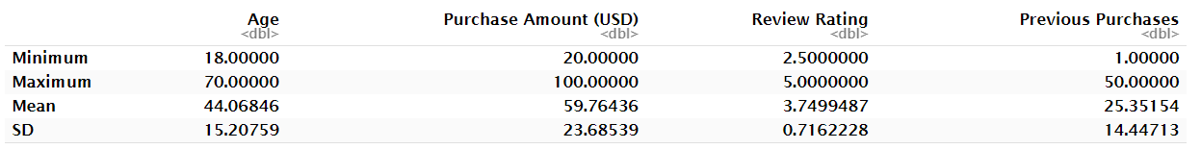
Table 1: Summary Statistics
In the dataset, the variable 'Age' ranged from 18 to 70 years (M=44.07,SD=15.21). The 'Purchase Amount (USD)' had a minimum of $20.00 and a maximum of $100.00 (M=59.76,SD=23.68). 'Review Rating' varied from 2.50 to 5.00 (M=3.75,SD=0.72). Finally, 'Previous Purchases' showed a range from 1 to 50 purchases (M=25.35,SD=14.45).
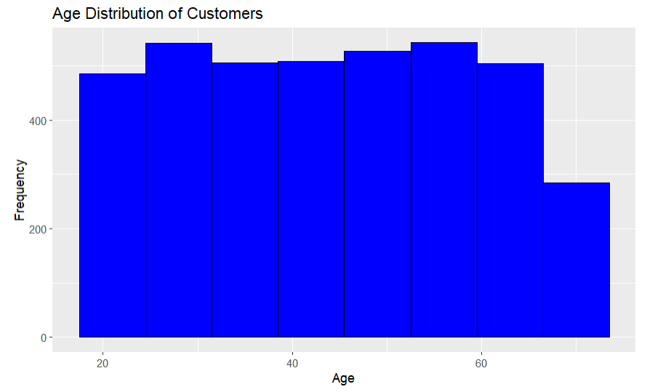
Figure 1: Age distribution
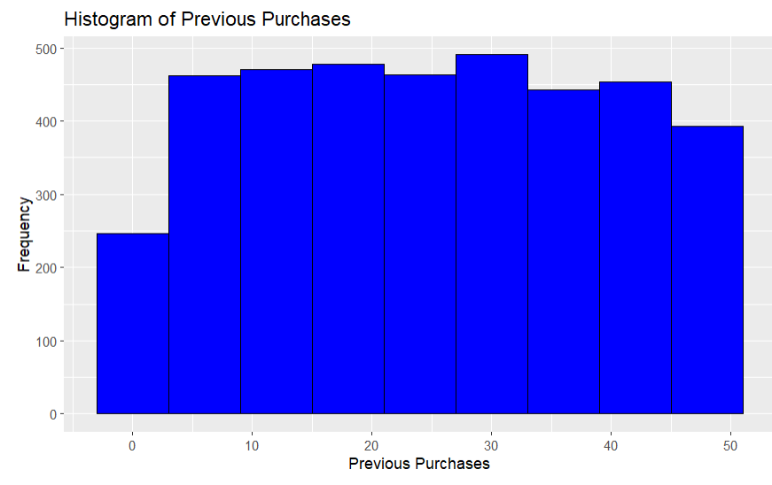
Figure 2: Histogram of previous purchases
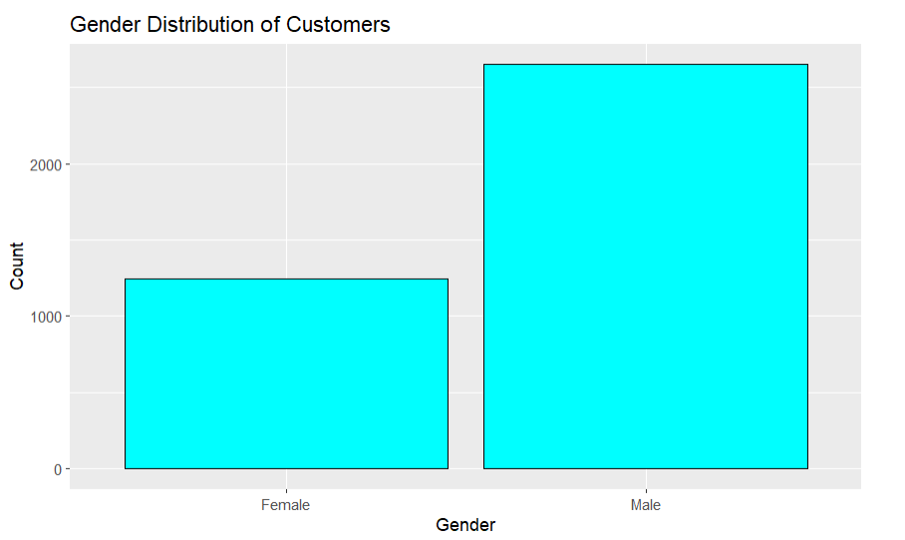
Figure 3: Gender distribution
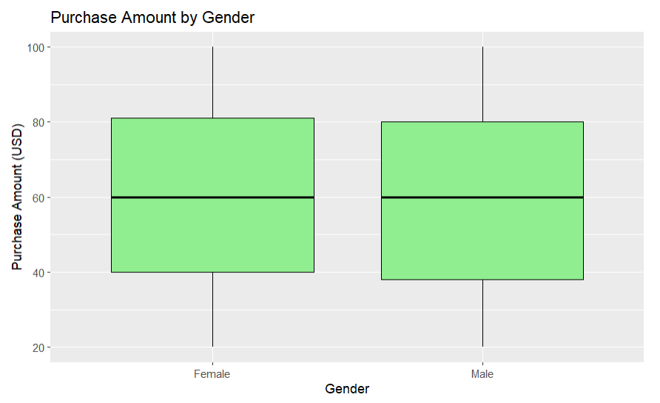
Figure 4: Distribution of purchase amount by gender

Hypothesis Testing
Null Hypothesis (H_{o}​): μ_{male}​=μ_{female},
Alternative Hypothesis (H₁​): μ_{male}​≠ μ_{female}
where μ_{male}​ and μ_{female} are the mean purchase amounts for male and female customers, respectively. The appropriate value for the parameter in the null hypothesis, which in this case is the mean purchase amount, is determined based on the assumption that there is no difference between the groups being compared.
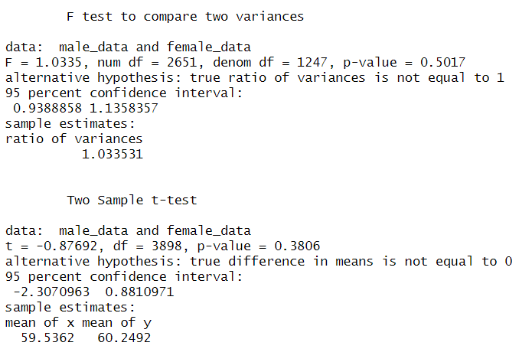
The two-sample t-test was conducted to compare the mean purchase amounts between male and female customers. The analysis included data from 2651 male customers (M = 59.54) and 1247 female customers (M = 60.25). The test revealed no significant difference in purchase amounts between males and females, t(3898) = -0.87692, p = 0.3806. The 95% confidence interval for the difference in mean purchase amounts ranged from -2.31 to 0.88, suggesting that the observed difference in means was not statistically significant and could be due to chance. This outcome indicates that gender does not play a substantial role in determining the purchase amount in this particular dataset.
Overall, the statistical analysis suggests that gender does not play a significant role in determining the variation in purchase amounts in this dataset. Both the F-test and the two-sample t-test point towards similarities in purchasing behaviors between male and female customers, as evidenced by the comparable variances and mean purchase amounts.

ANOVA
To conduct an Analysis of Variance (ANOVA) test for your study, we’ll be comparing the mean Purchase Amount (USD) across different categories: Accessories, Clothing, Footwear, and Outerwear. This test is vital to determine if the mean purchase amounts differ significantly among these categories, which can provide insights into consumer spending patterns across different product types.
Null and Alternative Hypotheses
- Null Hypothesis (H_{o}): There is no significant difference in the mean Purchase Amounts (USD) among the different categories (Accessories, Clothing, Footwear, Outerwear).
- Alternative Hypothesis (H₁): There is a significant difference in the mean Purchase Amounts (USD) among at least one pair of the different categories.
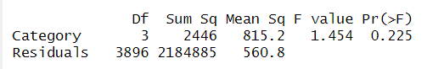
The results from the Analysis of Variance (ANOVA) conducted on the Purchase Amount (USD) across different categories - Accessories, Clothing, Footwear, and Outerwear - reveal insightful information about consumer spending patterns. A one-way between subjects ANOVA conducted to compare the effect of product category on purchase amount in Accessories, Clothing, Footwear, and Outerwear conditions. There was not a significant effect of product category on purchase amount at the p<.05 level for the four conditions [F(3, 3896) = 1.454, p = 0.225]. This result implies that the category of product - be it Accessories, Clothing, Footwear, or Outerwear - does not significantly influence the amount customers spend. This finding is particularly relevant for business strategies in retail and e-commerce, indicating that focusing on specific product categories under the assumption of different spending levels may not be as effective. It suggests that customer purchase decisions might be more influenced by factors other than the product category, such as brand loyalty, product quality, or individual preferences. Therefore, retailers might benefit more from strategies that focus on these aspects rather than on differentiating between product categories. This holistic approach could lead to more effective marketing strategies, inventory management, and overall customer engagement across all product segments.

Regression Analysis
A multiple linear regression is constructed in R to explore if factors such as age, subscription status, previous purchases, product category, and gender can be used to predict the purchase amount. Understanding these factors is crucial in e-commerce and retail marketing, as it helps in tailoring marketing strategies, predicting consumer behavior, and improving customer experience. By identifying key determinants of spending, businesses can optimize their product offerings, pricing strategies, and promotional activities.
Dependent Variable and its Importance
- Dependent Variable: Purchase Amount (USD).
- Importance: This variable represents the monetary value of customer transactions, a direct indicator of consumer spending behavior. Understanding what influences purchase amounts can help businesses in maximizing revenue, improving customer segmentation, and enhancing targeted marketing efforts.
Influencing Factors
- Age: Age can significantly influence purchasing power and preferences.
- Category (Accessories, Clothing, Footwear, Outerwear): Different product categories may attract different levels of spending.
- Gender (Male, Female): Gender might play a role in consumer preferences and spending patterns.
- Previous Purchases: This reflects customer loyalty and could indicate higher spending in frequent buyers.
- Subscription Status (Yes, No): Subscribers might have different spending behaviors compared to non-subscribers.
The regression analysis yielded the following results,
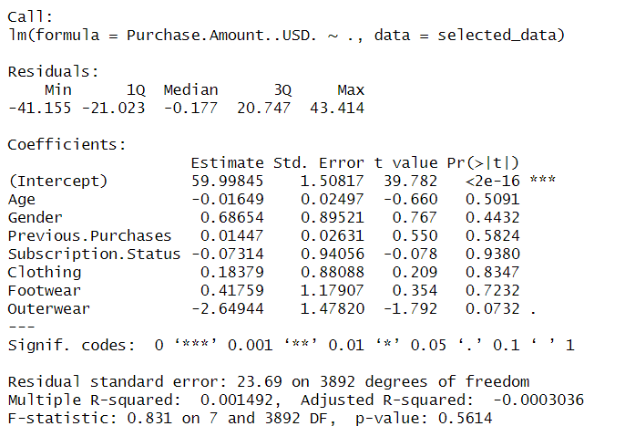
The linear regression analysis of your data offers some surprising results. Firstly, it appears that the expected purchase amount when other factors are not taken into account is around 60 USD. This is what the intercept value in the regression output tells us. Interestingly, factors that one might intuitively expect to influence purchase amounts, such as age, gender, the number of previous purchases, and subscription status, do not show a statistically significant impact. For instance, the analysis suggests a minor decrease in spending with increasing age and a slight increase for females compared to males, but these differences are not statistically significant. The same goes for the number of previous purchases and whether a customer has a subscription - these factors do not significantly alter the purchase amount. Another interesting aspect is the lack of significant differences in purchase amounts across product categories like Clothing, Footwear, and Outerwear, compared to Accessories. This might indicate that the customers’ spending does not vary much across these product types, at least not in the dataset analyzed. The lack of significant findings could be due to several reasons. It's possible that the sample of customers is quite homogeneous in their spending habits, or that these particular variables don't capture the main drivers of purchase amount in this context. It could also be that other, unmeasured factors have a more substantial influence on how much customers spend. Regarding the strength of the model, the R-squared value is very low, indicating that the model does not explain much of the variation in the purchase amounts. This is further supported by the p-value of the F-statistic, which suggests that the model is not statistically significant.
To improve the model, incorporating additional variables might be helpful. Variables such as specific customer preferences, detailed income information, or more nuanced behavioral metrics could potentially provide more insight into the factors driving purchase amounts.

Conclusion
To conclude, the comprehensive statistical analysis has yielded unexpected insights into online shopping behaviors, suggesting that age, gender, previous purchases, and subscription status do not significantly impact purchase amounts. These finding challenges traditional notions of consumer profiling and segmentation in e-commerce. Despite initial expectations, the study revealed that purchase amounts are not significantly affected by these demographic factors or by product categories, which include Accessories, Clothing, Footwear, and Outerwear. The low R-squared value of the regression model further indicates that the variability in purchase amounts is not well explained by the variables considered in the study. These results underscore the need to explore additional factors that might influence online consumer spending and point toward the potential of a more complex interplay of influences that extend beyond the scope of conventional demographics.

Appendix: R Code
```{r}
# Load necessary libraries
library(ggplot2)
library(dplyr)

# Read the data from CSV file
data <- read.csv("shopping_behavior_updated.csv")

# Calculate summary statistics for specific columns and transpose
summary_stats <- data %>%
reframe(
Min = c(min(Age, na.rm = TRUE), min(Purchase.Amount..USD., na.rm = TRUE),
min(Review.Rating, na.rm = TRUE), min(Previous.Purchases, na.rm = TRUE)),
Max = c(max(Age, na.rm = TRUE), max(Purchase.Amount..USD., na.rm = TRUE),
max(Review.Rating, na.rm = TRUE), max(Previous.Purchases, na.rm = TRUE)),
Mean = c(mean(Age, na.rm = TRUE), mean(Purchase.Amount..USD., na.rm = TRUE),
mean(Review.Rating, na.rm = TRUE), mean(Previous.Purchases, na.rm = TRUE)),
SD = c(sd(Age, na.rm = TRUE), sd(Purchase.Amount..USD., na.rm = TRUE),
sd(Review.Rating, na.rm = TRUE), sd(Previous.Purchases, na.rm = TRUE))
) %>%
t() %>%
as.data.frame()

# Set row names
rownames(summary_stats) <- c("Minimum", "Maximum", "Mean", "SD")
# Set column names
colnames(summary_stats) <- c("Age", "Purchase Amount (USD)", "Review Rating", "Previous Purchases")
# Print the summary statistics table
print(summary_stats)

# Visualizations:

# Histogram for Age Distribution
ggplot(data, aes(x=Age)) +
geom_histogram(binwidth=7, fill="blue", color="black") +
ggtitle("Age Distribution of Customers") +
xlab("Age") +
ylab("Frequency")

# Create histogram for Previous Purchases
ggplot(data, aes(x=Previous.Purchases)) +
geom_histogram(binwidth=6, fill="blue", color="black") +
ggtitle("Histogram of Previous Purchases") +
xlab("Previous Purchases") +
ylab("Frequency")

# Bar plot for Gender Distribution
ggplot(data, aes(x=Gender)) +
geom_bar(fill="cyan", color="black") +
ggtitle("Gender Distribution of Customers") +
xlab("Gender") +
ylab("Count")

# Boxplot for Purchase Amount by Gender
ggplot(data, aes(x=Gender, y=Purchase.Amount..USD.)) +
geom_boxplot(fill="lightgreen", color="black") +
ggtitle("Purchase Amount by Gender") +
xlab("Gender") +
ylab("Purchase Amount (USD)")

```
```{r}
# Create subsets of data based on gender
male_data <- filter(data, Gender == "Male")$Purchase.Amount..USD.
female_data <- filter(data, Gender == "Female")$Purchase.Amount..USD.

# F-test to compare variances
f_test_result <- var.test(male_data, female_data)

# Print the result of the F-test
print(f_test_result)

# Conduct two-sample t-test
# If F-test shows no significant difference in variances, use var.equal = TRUE
t_test_result <- t.test(male_data, female_data, var.equal = (f_test_result$p.value > 0.05))

# Print the result of the t-test
print(t_test_result)

```
```{r}
# Perform ANOVA
anova_result <- aov(Purchase.Amount..USD. ~ Category, data = data)

# Summary of the ANOVA result
summary(anova_result)

```
```{r}
library(tidyr)
# Select only the required columns
selected_data <- data %>%
select(Purchase.Amount..USD., Age, Category, Gender, Previous.Purchases, Subscription.Status)

# Create dummy variables for Gender and Subscription Status
selected_data <- selected_data %>%
mutate(Gender = ifelse(Gender == "Female", 1, 0),
Subscription.Status = ifelse(Subscription.Status == "Yes", 1, 0))

# Creating dummy variables for Category
# Using 'Accessories' as the baseline (not included in the dummy variables)
selected_data$Clothing <- ifelse(selected_data$Category == "Clothing", 1, 0)
selected_data$Footwear <- ifelse(selected_data$Category == "Footwear", 1, 0)
selected_data$Outerwear <- ifelse(selected_data$Category == "Outerwear", 1, 0)

# Remove the original 'Category' column
selected_data$Category <- NULL

# Conduct the regression analysis
regression_result <- lm(Purchase.Amount..USD. ~ ., data = selected_data)

# Display the regression results
summary(regression_result)

```

References
Moshref Javadi, M. H., Rezaei Dolatabadi, H., Nourbakhsh, M., Poursaeedi, A., & Asadollahi, A. R. (2012). An Analysis of Factors Affecting on Online Shopping Behavior of Consumers. International Journal of Marketing Studies, 4(5), 81. https://doi.org/10.5539/ijms.v4n5p81
Alfian, G., Octava, M. Q. H., Hilmy, F. M., Nurhaliza, R. A., Saputra, Y. M., Putri, D. G. P., Syahrian, F., Fitriyani, N. L., Atmaji, F. T. D., Farooq, U., Nguyen, D. T., & Syafrudin, M. (2023). Customer Shopping Behavior Analysis Using RFID and Machine Learning Models. Information, 14(10), 551. https://doi.org/10.3390/info14100551
Gull, M., & Pervaiz, A. (2018, April 1). Customer Behavior Analysis Towards Online Shopping using Data Mining. IEEE Xplore. https://doi.org/10.1109/IMTIC.2018.8467262
‌

‌

